Getting Started with PAX Fabric - Enterprise AI Analytics Pipeline

PAX Fabric - Enterprise AI Analytics Pipeline is an enterprise analytics workload for Microsoft Fabric that helps organizations collect, process, and prepare tenant-wide activity, usage, consumption, user, and agent data for reporting and analysis.
The workload provides a managed experience for deploying the required Fabric resources, configuring data collection, running the pipeline on demand or on a schedule, monitoring execution, and connecting the resulting Lakehouse data to ready-to-use reporting templates.
PAX Fabric - Enterprise AI Analytics Pipeline runs natively in Microsoft Fabric. Collected and processed data is stored as Delta tables in OneLake, allowing organizations to maintain their analytics workflow within their Fabric environment.

Contents
What You Can Do with PAX Fabric - Enterprise AI Analytics Pipeline 1
How PAX Fabric - Enterprise AI Analytics Pipeline Works 2
End-to-End Workload Flow 2
Fabric Resources Flow 2
Resources Created by the Workload 2
Before You Begin 3
Get Started 3
1. Create a PAX Fabric Pipeline Item 3
2. Deploy the Fabric Resources 4
3. Configure the Workload 4
Understanding PAX Configuration 5
Run the Pipeline 5
Create Recurring Schedules 6
Monitor Runs 6
Update Resource Definitions 7
Review the Lakehouse Output 7
Connect the PAX Report Templates 7
Related Fabric Resources 8

What You Can Do with PAX Fabric - Enterprise AI Analytics Pipeline
PAX Fabric - Enterprise AI Analytics Pipeline enables you to:
- Consolidate supported activity, usage, and consumption data in a single Lakehouse.
- Collect a selected historical date range or maintain a rolling dataset through recurring schedules.
- Enrich activity data with user, license, organizational, and agent context.
- Apply user or group filters to control the collection scope.
- De-identify user information where required.
- Produce raw, rolled-up, or combined output for different reporting requirements.
- Use incremental processing and checkpoint-based continuation for recurring data collection.
- Monitor on-demand and scheduled runs directly from the workload.
- Connect the generated Lakehouse tables to the supplied Power BI report templates.

How PAX Fabric - Enterprise AI Analytics Pipeline Works
The PAX Fabric Pipeline item is the central management experience for the workload. From this item, you can deploy resources, maintain configuration, start runs, create schedules, monitor execution, and open the related Fabric items.
The workload separates shared configuration from execution-specific parameters. Shared settings are maintained through the PAX Fabric Pipeline item and its Variable Library, while on-demand runs and schedules can supply their own collection parameters to the shared Data Pipeline.

End-to-End Workload Flow
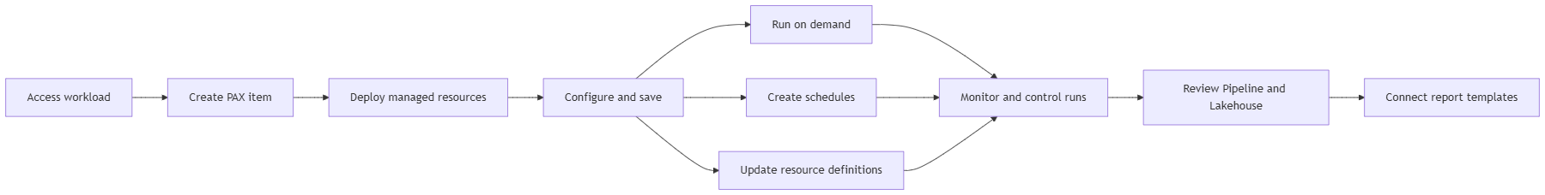

Fabric Resources Flow
The workload deploys and connects the Fabric resources that perform collection, transformation, storage, and reporting:
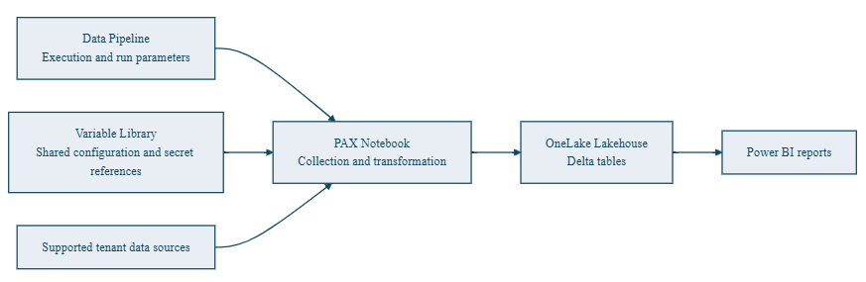

Resources Created by the Workload
When you deploy resources from a PAX Fabric Pipeline item, the workload creates and connects the following Fabric items in the selected workspace:
Resource | Purpose
Variable Library | Stores shared configuration, including identity references, Key Vault references, target schema, retention, concurrency, partitioning, and source settings.
Lakehouse | Stores processed activity, usage, consumption, user, agent, and dimensional data as Delta tables in OneLake.
Notebook | Contains the PAX collection and transformation logic and writes the processed output to the Lakehouse.
Data Pipeline | Orchestrates Notebook execution and supplies parameters for on-demand and scheduled runs.
These resources are created as separate Fabric items and can be opened from the workspace.

Before You Begin
Confirm that the following requirements are available:
- The PAX Fabric - Enterprise AI Analytics Pipeline workload is enabled and visible in your Fabric tenant.
- You have access to a capacity-backed Fabric workspace.
- You can create and manage Fabric items in the selected workspace.
- An approved Microsoft Entra application is available for the required data collection.
- The application credential is stored in Azure Key Vault.
- You know the application Client ID, Tenant ID, Key Vault URI, and Key Vault secret name.
- You have selected the Lakehouse schema in which PAX output tables will be created.
- You understand the required collection scope, privacy options, and retention period.
Enter the Key Vault secret name, not the credential value. The credential value must remain in Azure Key Vault.

Get Started

1. Create a PAX Fabric Pipeline Item
Open the PAX Fabric - Enterprise AI Analytics Pipeline workload landing page and select PAX Fabric Pipeline under Item types. Enter an item name, select the target workspace, and create the item.
The new item opens with an environment setup page that lists the Fabric resources required by the workload.

2. Deploy the Fabric Resources
Select Deploy Fabric Resources.
The workload provisions the Variable Library, Lakehouse, Notebook, and Data Pipeline. Deployment progress is displayed for each resource. If deployment is interrupted, selecting the deployment action again attempts to create only the missing resources.

3. Configure the Workload
Complete the shared configuration for PAX Fabric - Enterprise AI Analytics Pipeline:
Configuration | Description
Client ID | Application ID of the approved Microsoft Entra application.
Tenant ID | Directory ID containing the application registration.
Key Vault URI | URI of the Azure Key Vault that stores the application credential.
Key Vault Secret Name | Name of the Key Vault secret containing the credential.
Target Schema | Lakehouse schema in which PAX creates its output tables.
Keep Scratch | Controls whether intermediate files are retained after a run.
GitHub repository and reference | Identifies the source and version of the PAX modules used by the Notebook.
Max Concurrency | Controls the maximum number of partitions processed in parallel.
Partition Hours | Controls the size of each processing window.
Retention Period | Specifies the number of days prior to today for which data is retained in the output tables. Data older than the configured period is removed.
Save the configuration before starting a run. Saving synchronizes the applicable shared values to the managed Variable Library.

Understanding PAX Configuration
PAX Fabric - Enterprise AI Analytics Pipeline separates configuration according to how it is used and where it is maintained:
Configuration type | Where it is configured | Where it is stored or applied | Purpose
Shared configuration | PAX Fabric Configuration page | Saved in the PAX Fabric Pipeline item and synchronized to the managed Variable Library | Applies across on-demand and scheduled runs. This includes identity references, Key Vault references, target schema, retention, concurrency, partitioning, and source settings.
On-demand run parameters | Trigger dialog in the Run view | Passed to the shared Data Pipeline for the submitted run | Applies only to the manually triggered run. This includes the date window, dashboard scope, filters, privacy options, incremental processing, BYOD inputs, and advanced parameters.
Schedule parameters | Create pipeline schedule or Edit pipeline schedule dialog | Stored with the individual Fabric schedule and passed to the shared Data Pipeline when the schedule runs | Applies only to that recurring schedule. Each schedule can retain its own cadence, time zone, active period, enabled state, and execution parameters.
This model allows a single PAX Fabric Pipeline item to support multiple collection profiles while using one shared set of deployed resources.

Run the Pipeline
After saving the shared configuration, open the Run view and select Trigger.
The Trigger dialog allows you to review and configure:
- The collection start and end dates.
- Dashboard scope, including AI in One, M365, and ValueLens data.
- M365 Usage collection.
- Raw, rollup, rollup-plus-raw, and combined output options.
- User and Agent 365 information.
- Group and user filters.
- De-identification.
- Watermark-based incremental processing.
- Existing Purview or user-information input files.
- Checkpoint-based continuation.
- Additional advanced parameters.
Select Trigger to submit the run. The workload displays a confirmation when the Data Pipeline run has been queued.
For an initial run, consider using a limited date range and the minimum required collection scope. After confirming the expected output, expand the date range or enable recurring schedules as needed.

Create Recurring Schedules
Use Create schedule from the Run view to automate recurring collection.
PAX Fabric - Enterprise AI Analytics Pipeline supports:
- By-the-minute schedules.
- Hourly schedules.
- Daily schedules.
- Weekly schedules.
- Monthly schedules.
- Interval-based schedules.
Each schedule can retain its own:
- Enabled or disabled state.
- Start and end date.
- Time zone.
- Cadence and execution time.
- Collection and processing parameters.
Existing schedules can be refreshed, enabled, disabled, edited, or deleted from the Schedules section.

Monitor Runs
The Recent runs section shows both on-demand and scheduled executions.
For each run, you can review:
- Status.
- Start time.
- Duration.
- Invocation type.
Active runs refresh automatically and can be cancelled from the workload.
The Recent runs section provides a summary of run activity; it does not provide the complete error details for a failed pipeline run. To investigate a failure:
1. Select Open pipeline monitor.
2. Open the Data Pipeline run history.
3. Select the corresponding failed run.
4. Review the failed activity and its error details.

Update Resource Definitions
When a newer workload-managed definition is available, Update resource definitions becomes available in the PAX item.
The update operation can selectively refresh the managed Notebook, Data Pipeline, or Variable Library definition while preserving:
- The Lakehouse and its Delta tables.
- Existing Fabric item IDs.
- Existing schedules.
- Configuration values entered through the PAX item.
Review the update confirmation before proceeding because manual changes made directly to managed resources can be overwritten.

Review the Lakehouse Output
Select Open Lakehouse from the PAX Fabric Pipeline ribbon.
The Lakehouse contains the Delta tables produced by successful runs. Available tables depend on the selected collection scope and processing options. The configured target schema is used to organize the workload output.
You can use the Lakehouse for:
- Data review and exploration.
- SQL-based analysis through the Lakehouse SQL analytics endpoint.
- Power BI reporting.
- Other approved downstream analytics solutions.

Connect the PAX Report Templates
The PAX-Fabric GitHub repository provides Power BI template files for:
- M365 Usage
- AI in One
- ValueLens

Download the template that corresponds to the data collected by your PAX pipeline and open it in Power BI Desktop.
Each template requires:
Parameter | Source
SQL Endpoint | Copy the SQL connection string from the provisioned Lakehouse under Settings > SQL analytics endpoint.
Lakehouse Name | Use the name of the Lakehouse provisioned for the PAX item.
Schema | Use the Target Schema configured in the PAX Fabric Configuration page.
After entering the parameters, select Load and sign in with an organizational account that can access the Lakehouse.
The selected report template must correspond to data included in a successful PAX run.

Related Fabric Resources
The Variable Library, Lakehouse, Notebook, and Data Pipeline are separate Fabric items. Deleting the PAX Fabric Pipeline item should not be assumed to delete these resources. Review them individually and retain or remove them according to your requirements.

